06th February 2018

**YOKOHAMA to Expand Passenger-Car Tyre Production Capacity in India**

YOKOHAMA will expand the production capacity of its passenger-car tyre manufacturing and sales subsidiary in India – Yokohama India Pvt. Ltd. (Yokohama India). The expansion will boost Yokohama India’s annual production capacity from 700,000 to 1,530,000 tyres, an increase of 830,000. With growth in India’s automobile market driving strong sales of tyres, the Company decided to expand local production capacity to avoid capacity shortfalls over the medium term. The total planned investment will come to 3.8 billion rupees (about ¥6.6 billion). Construction of the new facilities is expected to start in March this year, with production scheduled to begin in the fourth quarter of 2019.   
  
Yokohama Rubber established Yokohama India in April 2007 as a tyre sales subsidiary. The subsidiary began local production of passenger-car radial tyres in July 2014 after completion of its tyre plant at the Bahadurgarh Industrial Estate in the state of Haryana. The plant’s new facility will manufacture original equipment tyres for local car makers as well as replacement tyres, including tyres for passenger cars and SUV tyres.

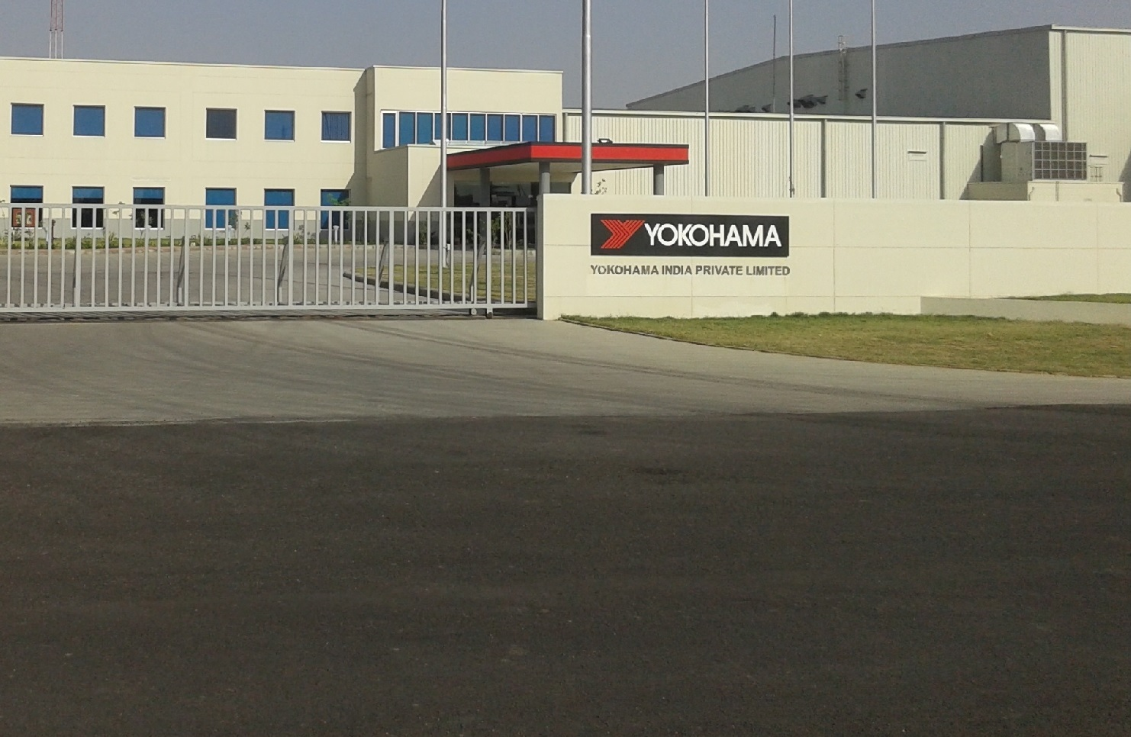*Yokohama India Pvt. Ltd.*

###### Outline of Yokohama India

Representative: Yoshiaki Mori  
Head office: Gurugram, Haryana  
Established: April 2007   
Plant location: Haryana Bahadurgarh Industrial Estate  
Plant site area: Approx. 100,000 square meters (about 25 acres)  
Start-up date: July 2014  
Products: Replacement tyres for passenger cars   
Production capacity: Currently 700,000 tyres per year, 1,530,000 after expansion (new facilities expected to come on line in fourth quarter of 2019)  
Employees: 474 (as of December 2017)